David Kelly B00060572

Summary of Process Monitors

The first process-monitor I downloaded and installed was htop. I downloaded a zip file from the internet and unzipped the file through the command line, like the gnuplot program we installed in lab 1.
While configuring htop I ran in to errors with required packages that weren't installed on my virtual machine. I had to open software installer and get developer files in order to complete the configure. After getting the packages it was pretty plain sailing from there. I installed the program as root and saved it. Meaning any user on the computer could access the program and not just my user.
Features
htop is a command line interface process-monitor. To execute htop I simply typed htop in to my command line. This command cleared the Konsole and displayed a new screen filled with data.
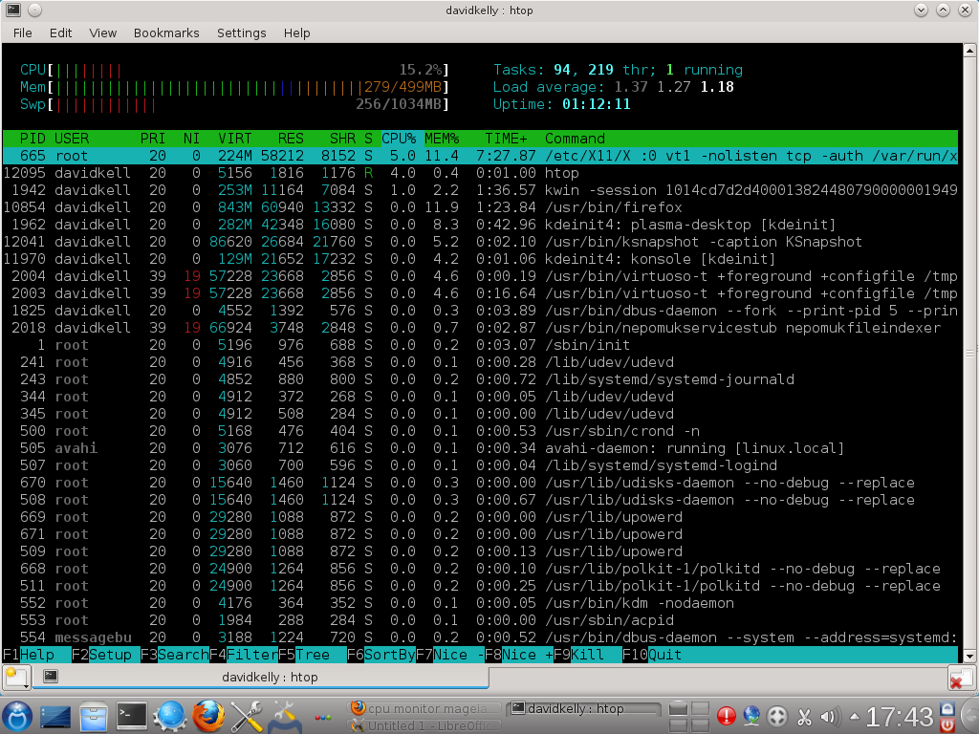

The image shows my Konsole. The top left bars and percentage beside CPU, Mem & Swp (secondary memory) show the usage rates of each at a given moment in time. The color of the bars indicate the priority value of the process (green = normal priority, red = kernel priority). The top right shows tasks running and previous tasks that are finished with a load average time and the uptime of the computer.
The table taking up most of the console is a process id table giving detailed information about each individual process such as....
the user running the process, the % of CPU the individual process is using, the length of time the process has been running & the directory where the process is running from.

htop allows the user to organise and rearrange the data view by columns and search for a keyword to find a process. After finding a process you are then able to adjust it's priority or allocate more CPU usage to the process through the Nice - & Nice + functions or Kill the process by pressing the F9 key.
David Kelly B00060572

The second process-monitor I downloaded was Conky a GUI styled program. Conky was easier to install it had all the necessary source code required to configure and I also saved it as root, giving all users access to the program.
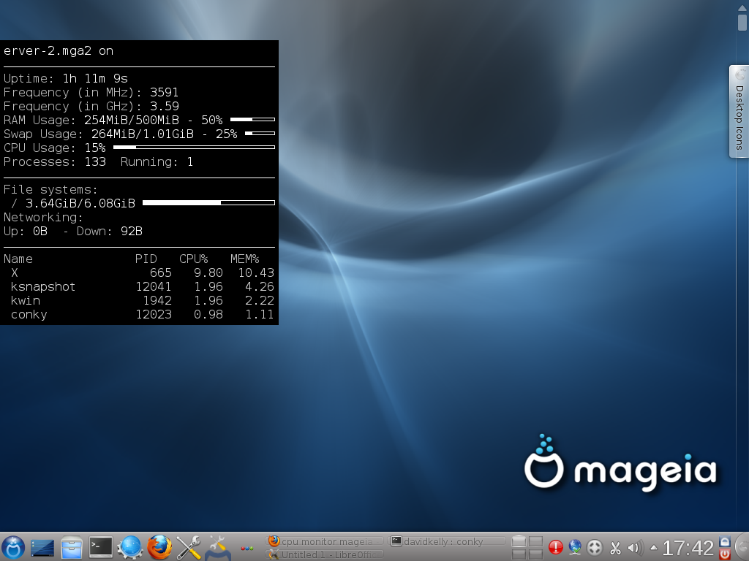
Conky opened itself in the foreground and in order to keep it running while I used other programs I had to use the command line to change it's running to the background. Conky wasn't a very pretty GUI but from what I gather the style is easily tailored by the user.

Conky showed a lot of the same information htop did, all be it in a different layout and style, what the default Conky setup showed that the default htop interface didn't was network monitoring & the used memory in secondary memory. Conky only showed a fraction of the PID's in comparison to htop.
I didn't get to use Conky for very long due to time restraints in class but I did do some more research when I got home and Conky really doesn't give you any control over your process like htop does, it is very literally a process monitor. Giving the user graphical feedback from their machine and not much more.

Finally I downloaded Monit from the Mageia Software Installer the same way as Conky. Monit ran in the Konsole. I had to do some research on Monit because I knew very little about it. Monit monitors and manages processes and can automatically react if any error situation occurs. Monit can restart or refresh a program and send a message alert to notify the user of it doing so. I guess I needed to use Monit for a little longer to get any information from working on it rather than reading about it.

